### Exercises 1.2 (note: I changed the numbers on #7, 9, and 10 and I changed video store to Disney+ on #7. I changed the movies on #9.)

1. List the elements of the set “The letters of the word Mississippi.”
2. List the elements of the set “Months of the year.”
3. Write a verbal description of the set {3, 6, 9}.
4. Write a verbal description of the set {a, i, e, o, u}.
5. Is {1, 3, 5} a subset of the set of odd numbers?
6. Is {A, B, C} a subset of the set of letters of the alphabet?

Create a Venn diagram to illustrate each of the following:

1. A survey was given asking whether people watch movies at home from Netflix, Redbox, or Disney+. Use the results to determine how many people use Redbox.

* 70 only use Netflix, 30 only use Redbox
* 5 only use Disney+, 6 use only Disney+ and Redbox
* 14 use only Netflix and Redbox, 20 use only Disney+ and Netflix
* 7 use all three, 25 use none of these

1. A survey asked buyers whether color, size, or brand influenced their choice of cell phone. The results are below. How many people were influenced by brand?

* 5 said only color, 8 said only size
* 16 said only brand, 20 said only color and size
* 42 said only color and brand, 53 said only size and brand
* 102 said all three, 20 said none of these

1. Use the given information to complete a Venn diagram, then determine: a) how many students have seen exactly one of these movies, and b) how many have seen only *Star Wars Episode IX*.

* 25 have seen *Inception* (*I*), 45 have seen *Star Wars Episode IX (SW)*
* 19 have seen *Vanilla Sky (VS),* 18 have seen *I* and *SW*
* 17 have seen *VS* and *SW,* 11 have seen *I* and *VS*
* 9 have seen all three
* 2 have seen none of these

1. A survey asked 100 people what alternative transportation modes they use. Use the data to complete a Venn diagram, then determine: a) how many people only ride the bus, and b) how many people don’t use any alternate transportation.

* 40 use the bus, 25 ride a bicycle
* 33 walk, 7 use the bus and ride a bicycle
* 15 ride a bicycle and walk, 20 use the bus and walk
* 5 use all three

Given the qualified propositions: A) Determine the two sets being described B) Determine if the sets described are Subsets, Overlapping Sets or Disjoint sets. C) Illustrate the situation using sets.

1. All Terriers are dogs.
2. Some Mammals Swim. (The second set is not clearly defined but is implied)
3. No pigs can fly.
4. All children are young.
5. Some friends remember your birthday.
6. No lies are truths.

Answers to the original exercises

1. { m, i, s, p}

2. {January, February, March, April, May, June, July, August, September, October, November, December}

3. The set containing multiples of 3 from 3 to 9

4. The set containing the vowels

5. Yes, {1, 3, 5} is a subset of the odd numbers.

6. Yes, {A, B, C} is a subset of the letters of the alphabet.



11 A) Terriers and dogs

B) Subsets

C)

Dogs

Terriers

12 A) Mammals and fish

B) Overlapping

C)

Fish

Mammals

13 A) Pigs and things that can fly

B) Disjoint

C)

Things that can fly

Pigs

14 A) Children and people that are young

B) Subset

C)

People that are young

Children

15 A) There are at least two ways this can be interpreted.

Friends and people that remember your birthday

or friends and friends that remember your birthday

B) Overlapping or subset (depending on how this is interpreted)

C)

People that remember your birthday

Friends

Friends

Friends that remember my birthday

16. A) Lies and truths

B) Disjoint

C)

truths

lies

Added exercises

### 1.2

1.  Suppose someone wants to conduct a study to learn how teenage employment rates differ between boys and girls and between honor students and others. For each teenager in the study, they will need to record the answers to these three questions:

·         Is the teenager a boy or a girl?

·         Is the teenager an honor student or not?

·         Is the teenager employed or not?

Explain what each of the regions in the following Venn Diagram represent.

**A__________________________________________________________**

**B__________________________________________________________**

**C__________________________________________________________**

**D__________________________________________________________**

**E__________________________________________________________**

**F__________________________________________________________**

**G__________________________________________________________**

**H__________________________________________________________**

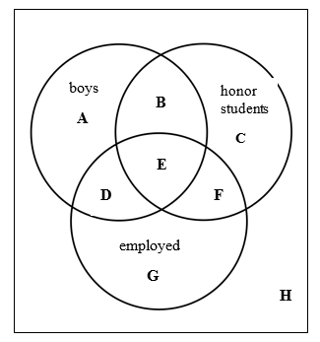

Answers:

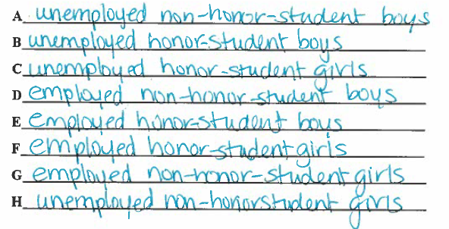

2.   Students were surveyed to see if they used smart phones, tablets, or both.

·         85 students said they used smart phones

·         50 students said they used tablets

·         10 students said they use both

·         5 students said they used neither

Draw a Venn Diagram to help you answer the following. Show your calculations.

How many students were surveyed?_____________

Answers:

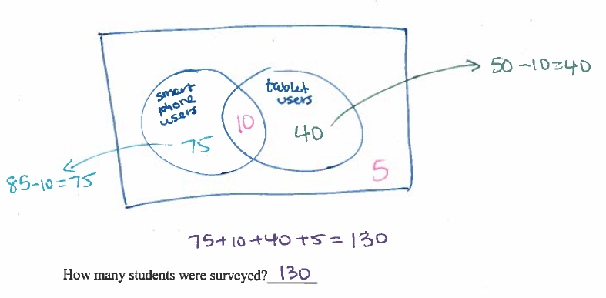

3. The Venn Diagram below shows the numbers of students in grade 5 at an elementary school who have enrolled for keyboard (K), guitar (G), and drum classes. Fill in the blanks.

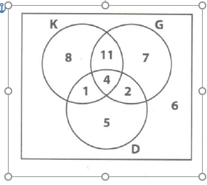

_____ students enrolled for keyboard class

_____ students enrolled for keyboard class only

______students didn’t enroll at all

_____ students took all three classes

_____ students enrolled for guitar and drum

_____ students enrolled for guitar and drum only

Answers:

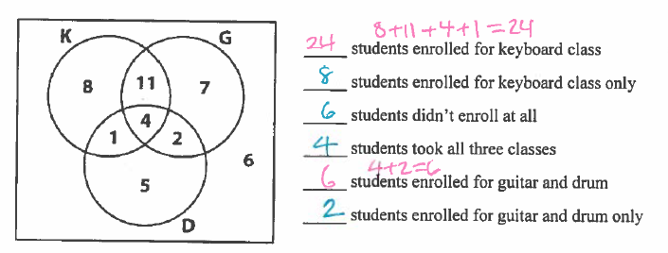

A poll asked 100 coffee drinkers whether they like cream or sugar in their coffee. The information was organized in the following Venn Diagram.

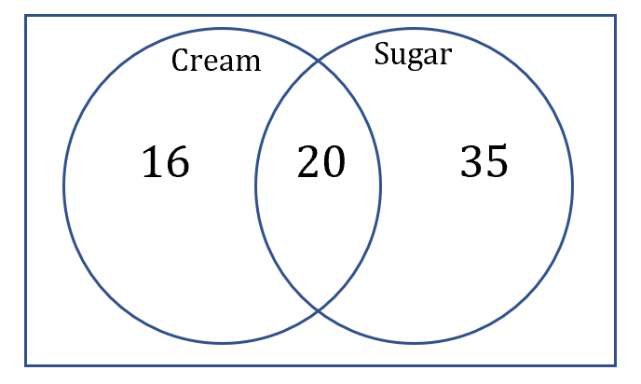

a.       How many coffee drinkers like cream?

b.      How many coffee drinkers like sugar?

c.       How many coffee drinkers like sugar but not cream?

d.      How many coffee drinkers like cream but not sugar?

e.       How many coffee drinkers like cream and sugar?

f.        How many coffee drinkers like cream or sugar?

g.       How many coffee drinkers like neither cream nor sugar?

 110 dogs were asked “Why do you like to eat garbage?”

·   89 said “It tastes great!”

·   87 said “It’s more filling!”

·   68 said “It tastes great!” and “It’s more filling!”

a.       Draw a Venn diagram to represent this information

b.      How many said “It’s more filling!” but didn’t say “It tastes great!”?

c.       How many said neither of those things?

d.      How many said “It’s more filling!” or said “It tastes great!